2024 Order Form

Please complete the following in full and make checks payable to:

The First Amendment Foundation 317 East Park Ave, Lower Level

Tallahassee, FL 32301

Phone: 850-224-4555

Ordering and Payment is easier online!
Go to: https://floridafaf.org/products-services/

**Please indicate quantity ordered**

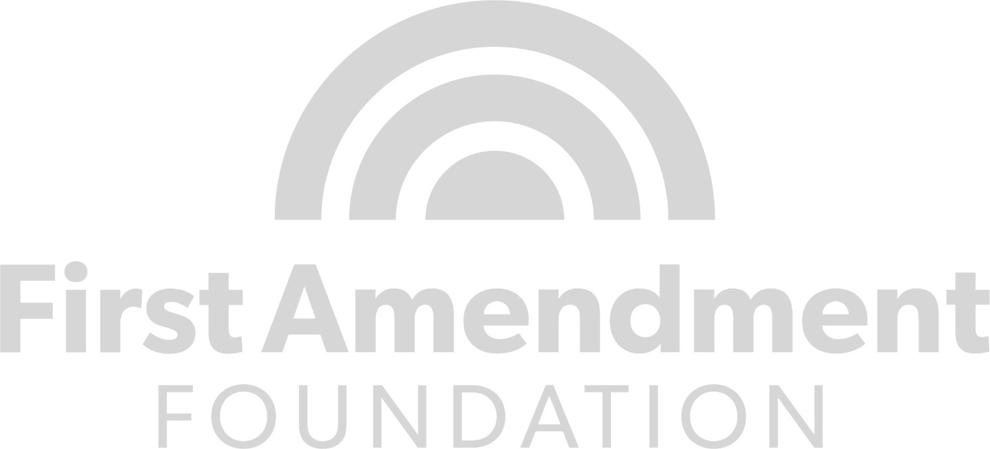
2024 Government-in-the-Sunshine Manual (vol. 46):

Price per copy: $35.00
Pocket Guide: $12.00

Please check out our other products and information on trainings available on our website, www.floridafaf.org.

- Orders must be pre-paid prior to shipment.  - We do not accept purchase orders.  - Federal Tax ID #: 59-2449379  - All orders shipped lowest rate possible. You may request expedited shipping for an additional fee.  - IF TAX-EXEMPT, please provide a copy of your tax exemption certificate. | Subtotal: $  Shipping & Handling: $ Sales tax (6% + county surtax): $
 | Total: $

Name Organization Address City State Zip Email

